# Musical Tone Generator

**OBJECTIVE:**

To generate musical tone [sa re ga ma pa da ni sa] with each Tone has time duration 0.5 sec

**ABSTRACT:**

A musical-tone generator based on physical modeling of sound production mechanisms is presented. For the purpose of making this scheme general for a wide class of musical instruments, the nonlinear part of the tone-generator is modeled by a neural network. The system learns its parameters and the nonlinearity shape by means of nonlinear identification procedures based on waveform or spectral matching. Two possible applications of this model are discussed: sound compression can be obtained when considering the system as a nonlinear predictor, while sound synthesis can be obtained by adding control inputs to the network and by training the system to respond as desired.

**INTRODUCTION:**

An electronic musical instrument such as an electronic piano has a musical tone generation structure that closely simulates and reproduces musical tones with nuances of musical expressions with fidelity to acoustic musical instruments such as acoustic pianos. In the casing of the electronic piano, speakers are attached to a speaker attachment plate, which is placed substantially horizontal, such that front sides of the speakers are directed upwards. The sounds radiated from the front sides of the speakers are reflected by a reflector board which is hinged to close or open at a prescribed angle of inclination with respect to a top board, so that reflected sounds are transmitted towards the audience. Enclosures are provided inside of the casing below the speaker attachment plate and contain mufflers having a relatively small thickness therein. Through holes whose openings are directed downwards are formed to penetrate through a bottom plate of the enclosures, wherein the total area of openings of the through holes is larger than the total area of the speakers. Sounds radiated from the backsides of the speakers propagate through the enclosures and are transmitted towards the floor via the through holes, so that reflected sounds are transmitted towards the audience

through the air. Further, the electronic piano as a whole vibrates in response to vibrations caused by the speakers. Thus, the electronic piano produces mixed sounds that reproduce acoustic musical tones having the nuances of musical expression of an acoustic piano.

**SOFTWARE REQUIREMENT/DESCRIPTION:**

scilab-6.1.0 (64-bit) Desktop

**WORKING CODE:**

## clc ; close ; clear ;

frequency =[240 254 302 320 358.5 380 451 470]; *//CorrespondingFrequency*

fs =8000; *//Sampling Frequency*

## no =8;

N =1:4000; *// Total No.of Samples for Each tone*

## temp =[]; for i =1:no

y = sin(2*3.14*(frequency(i)/fs)*N); temp =[temp y];

## end length(temp); subplot(1,2,1); plot(frequency);

title('Input frequency'); subplot(1,2,2); plot(temp); title('Output');

## sound (temp,fs);

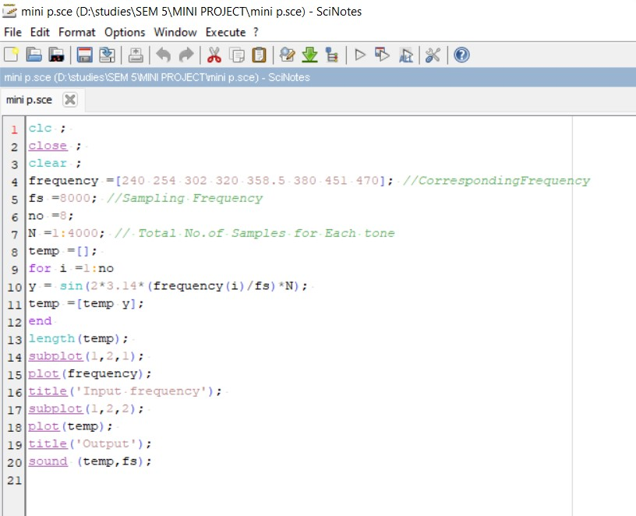

**OUTPUT:**

1. **FREQUENCY:**

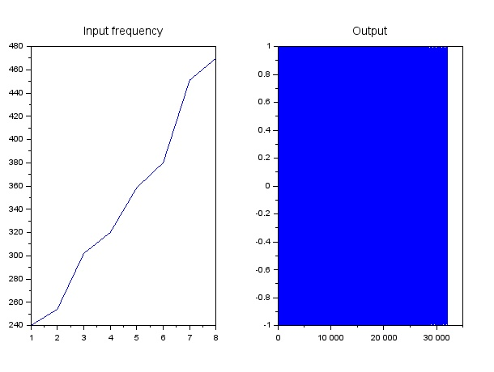

**APPROACH/METHODOLOGY/DISCUSSION:**

Based on the given Frequency, the code runs accordingly by selecting the respective lowerand higher frequencies of the row and column. Then the given Frequency generates appropriate sound signal

**CONCLUSION:**

The output of musical tone generation with each tone duration gap 0.5 seconds has been generated with theaudio signals successfully.

**REFERENCES:**

https://knowledgecenter.ubt- uni.net/cgi/viewcontent.cgi?article=2140&context=conference

**APPENDIX:**

Tools Used: SCILAB Software

# Musical Tone Generation with each Tone has time duration 0.5 sec

TEAM MEMBERS NAME WITH REGISTER NUMBER

### B Devananda Reddy - RA2111004010086

Masku Rahul - RA2111004010087